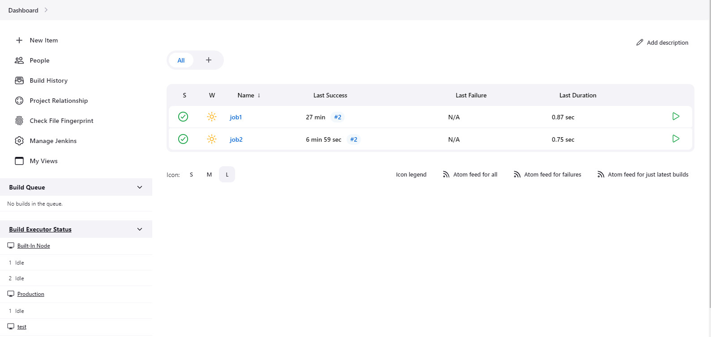

Job1 > Configure

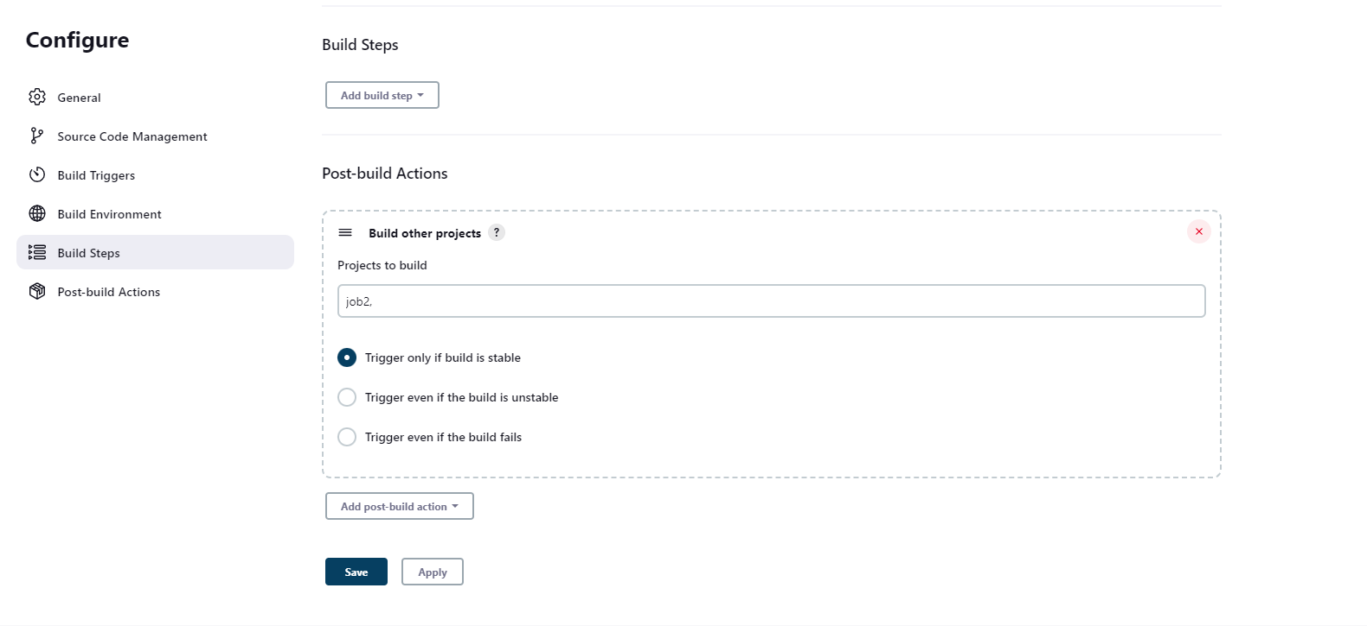

Then if I schedule job 1 we can see job 2 in queue

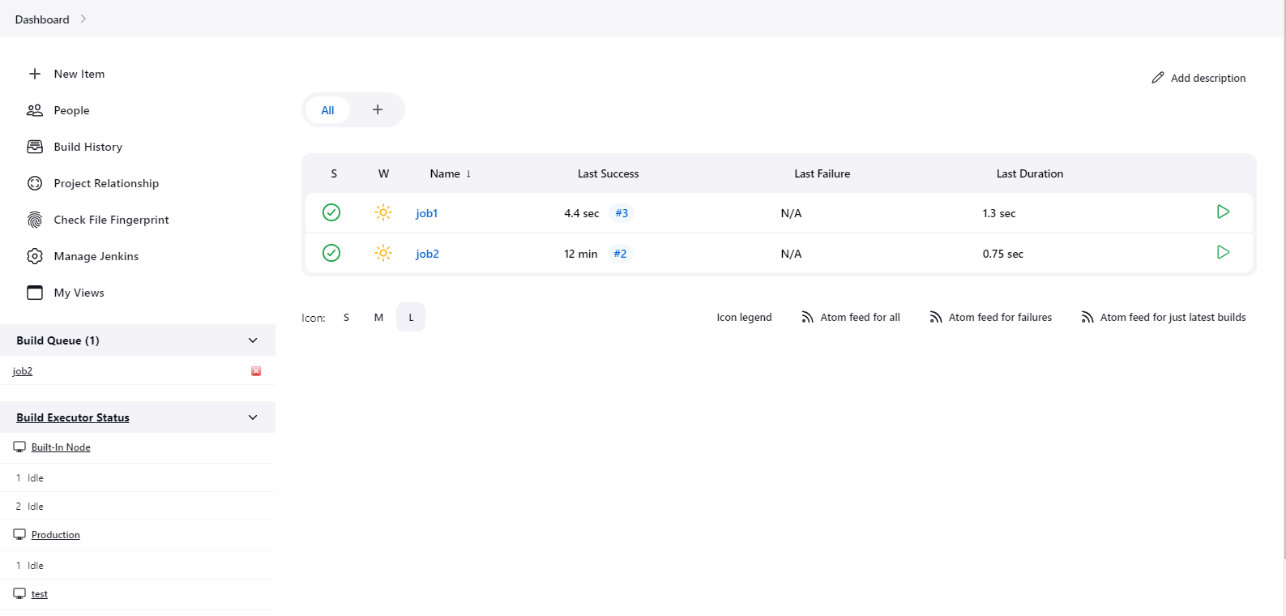

As we can se once job 1 executed job 2 is also executed

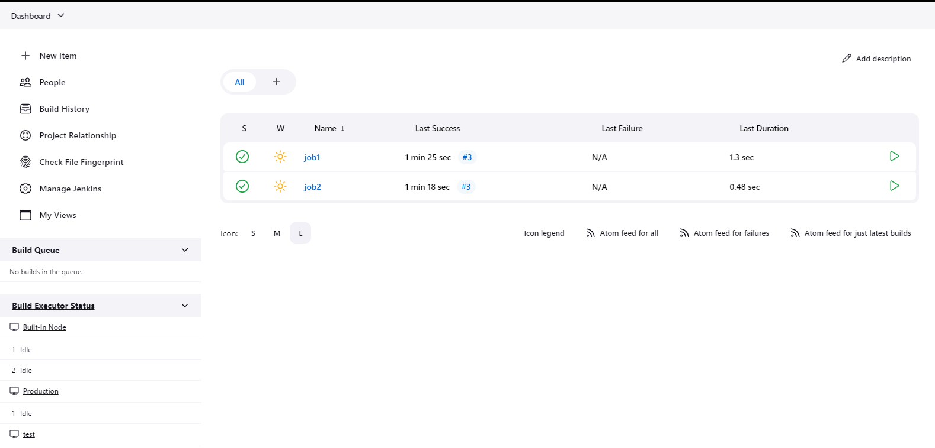

If we check console output of latest job we can clearly see it is triggering job 2

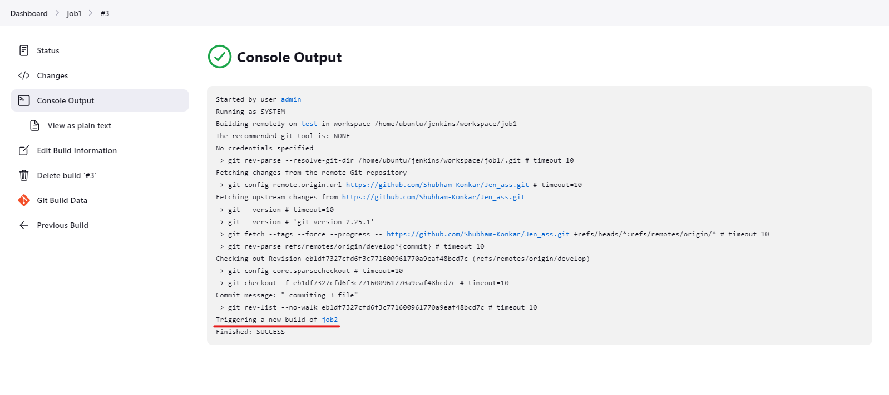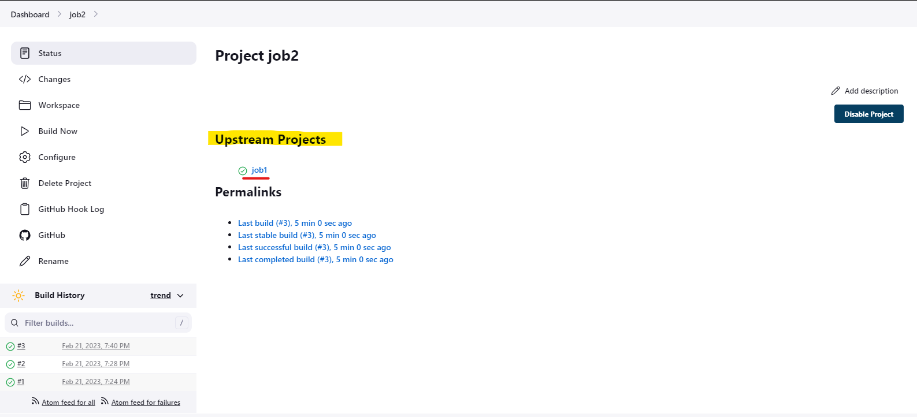

This is how we created pipline between 2 jobs we created